
Name: ______________________ Time: 20 minutes (strict) Total Marks:____/11 Weighting : 2%
Year 10
OLNA class

Quiz 9 - 2021

Measurement

Resources: No calculator allowed

1. | 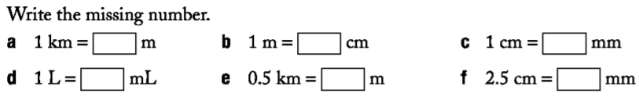
2. | 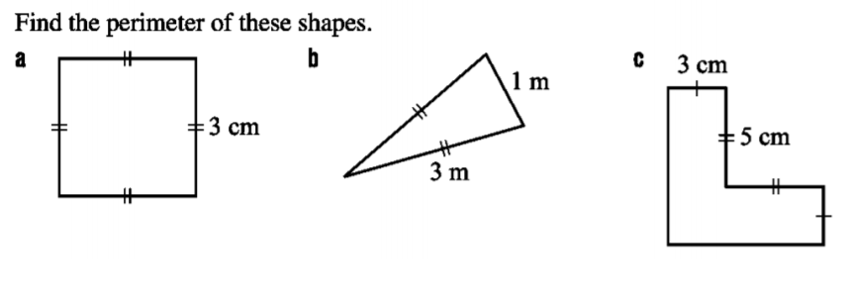
3. | 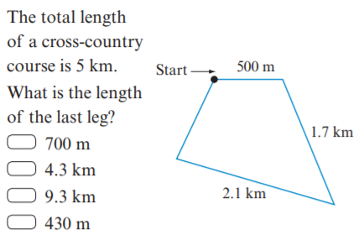
4. | A triangle has an area of 40 cm². If it is 8 cm high, how long is its base?

End of Test

